**JUnit Testing Exercises**

**Exercise :1-Setting up j unit**

**Calculator.java**

package com.example;

public class Calculator {

public int add(int a, int b) {

return a + b;

}

}

**CalculatorTest.java**

package com.example;

import org.junit.Test;

import static org.junit.Assert.assertEquals;

public class CalculatorTest {

@Test

public void testAdd() {

Calculator calc = new Calculator();

int result = calc.add(2, 3);

assertEquals(5, result);

}

}

**pom.xml**

<project xmlns="http://maven.apache.org/POM/4.0.0"

xmlns:xsi="http://www.w3.org/2001/XMLSchema-instance"

xsi:schemaLocation="http://maven.apache.org/POM/4.0.0

http://maven.apache.org/xsd/maven-4.0.0.xsd">

<modelVersion>4.0.0</modelVersion>

<groupId>com.example</groupId>

<artifactId>junit-demo</artifactId>

<version>1.0-SNAPSHOT</version>

<dependencies>

<dependency>

<groupId>junit</groupId>

<artifactId>junit</artifactId>

<version>4.13.2</version>

<scope>test</scope>

</dependency>

</dependencies>

</project>

**OUTPUT:**

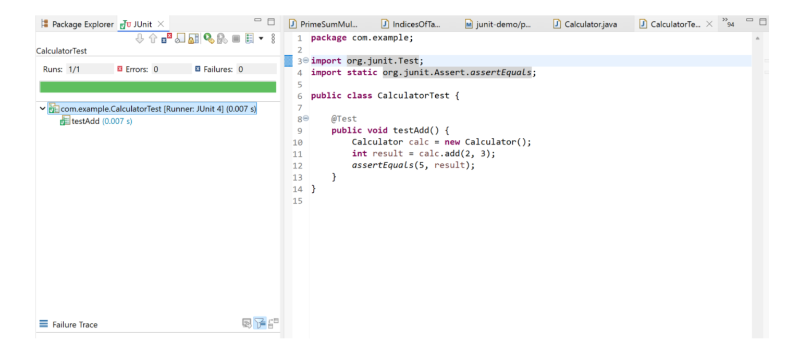

**Exercise:3**

**AssertionsTest.java**

package com.example;

import org.junit.Test;

import static org.junit.Assert.*;

public class AssertionsTest {

@Test

public void testAssertions() {

// assert equals

assertEquals(5, 2 + 3);

// assert true / assert false

assertTrue(5 > 3);

assertFalse(5 < 3);

// assert null / assert not null

assertNull(null);

assertNotNull(new Object());

}

}

**OUTPUT:**

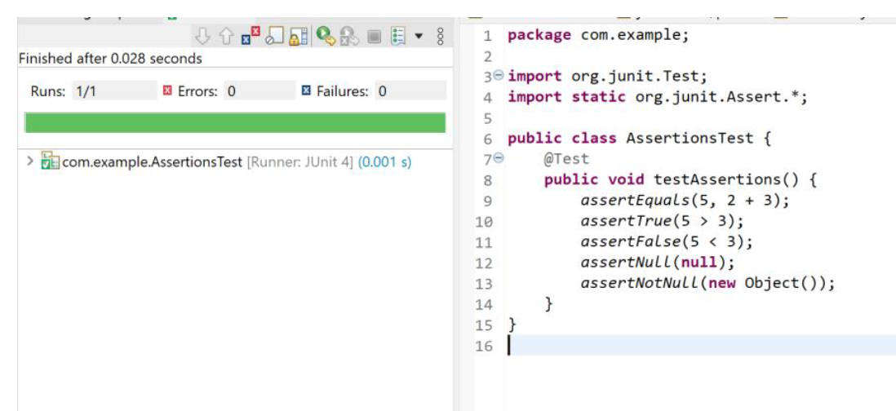

**Exercise:4**

**Arrange-Act-Assert (AAA) Pattern, Test Fixtures, Setup and Teardown Methods in JUnit**

**CalculatorTest.java**

package com.example;

import org.junit.Before;

import org.junit.After;

import org.junit.Test;

import static org.junit.Assert.*;

public class CalculatorTest {

private Calculator calc;

@Before

public void setUp() {

System.out.println("Before each test: Setup Calculator");

calc = new Calculator();

}

@After

public void tearDown() {

System.out.println("After each test: Teardown Calculator");

calc = null;

}

@Test

public void add_returnsCorrectSum() {

// Arrange done in @Before

int a = 2, b = 3;

// Act

int result = calc.add(a, b);

// Assert

assertEquals(5, result);

}

}

**OUTPUT:**

